Topic 2: LINEAR INEQUALITIES
With a well-grounded foundation in linear equations, we can piece out all workable concept, method or strategy for linear inequalities, which literally has us replacing the equality “=” with the inequality symbols (< or > or $≤ or ≥).$
Objectives: In this session, you will be able to:
- Solve problems on linear inequalities in one variable.
- Solve problems on linear inequalities in two variables.
- Understand and express combined inequalities.
VARIABLES IN LINEAR INEQUALITIES
The solutions for linear inequalities follow the same pattern as the solutions for linear equations. In essence, the goal is to ensure balance on both sides of the inequality, while reducing to wards the unknown, via subject of formula or otherwise.
TRIVIA
When dividing by a negative value (e.g. -1), the inequality reverts to its direct opposite. The process holds when multiplying by a negative value as well.
Example
$-2x<5→x>\frac{-5}{2}\left(<reverts to>\right)$
$-3x≥9→x≤-3\left(≥reverts to≤\right)$
NUMBER LINE FOR INEQUALITIES
- A blank circle shows a strictly less or strictly greater inequalities. A shaded / filled circle shows a less or equal / greater or equal inequality.
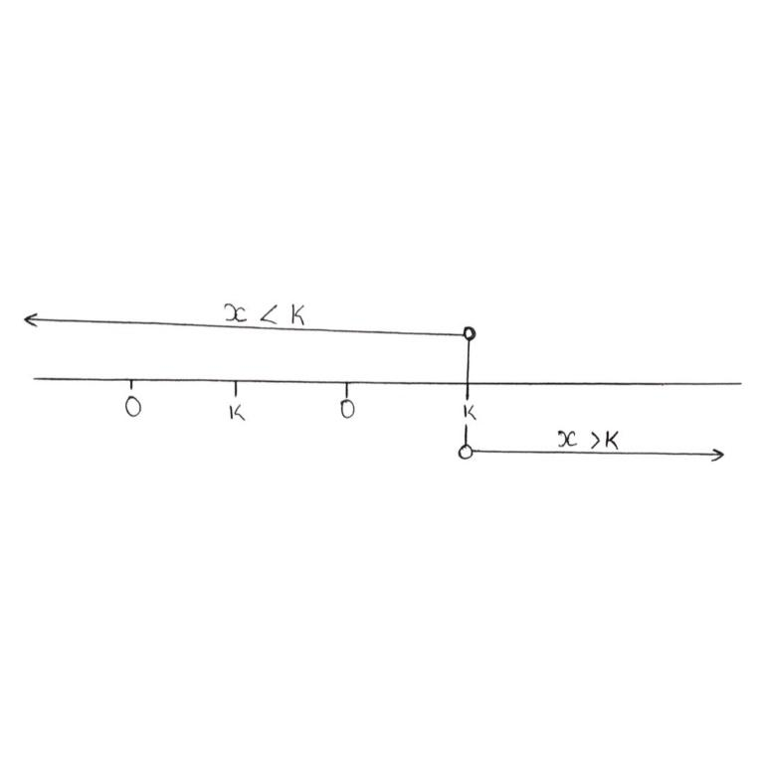

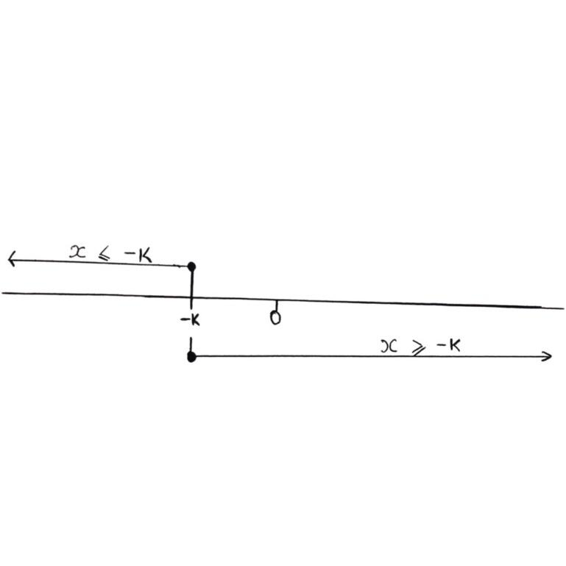

Inequalities can also be combined into range of values, to express the bounds that confine the variable. This can also be represented on the number line.

Example:
- $-3<x <5$
$$This simply means that x<5 and -3 < x$$
This implies that x<5 and x > -3 are the bounds confining x.
- $-3<x ≤3$
$$This means - 3< x and x≤3$$
This implies that x>-3 and x $≤$ 3 are the bounds confining x.
- |x| $≤3$
This means that x$≤3 and - x ≤ 3$
This implies that x$≤3 and - x ≤ 3 (lie -3≤ x ≤ 3$

LINEAR INEQUALITIES IN ONE VARIABLE
These are linear inequalities with only one variable or unknown. It suffices to solve via subject of formula.
Example
- Evaluate 4x +7<5x+13
4x +7<5x+13
Collect like terms,
4x – 5x <13 – 7
-x <6
x >-6
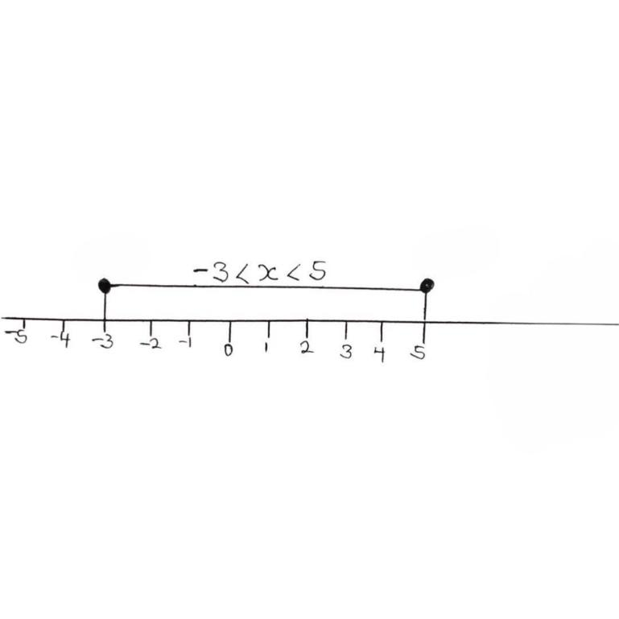

- Solve 3(x – 6) $≤9\left(x-1\right)$
3x – 18 $≤ 9x - 9$
3x – 9x $≤- 9 +18$
$$- 6x ≤9$$
$$x ≥\frac{-3}{2}$$
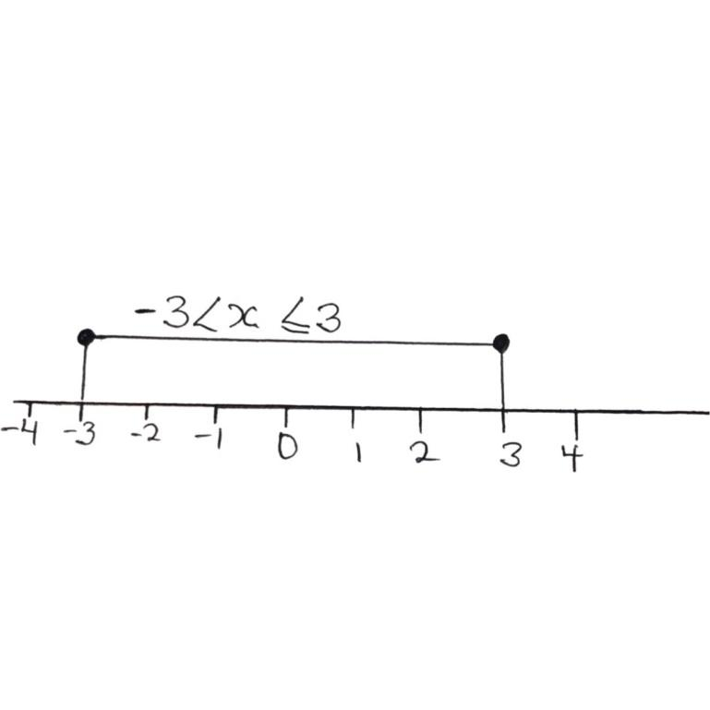

- Solve 7 $≤3 - 2x <13$
7 $≤3 - 2x <13$
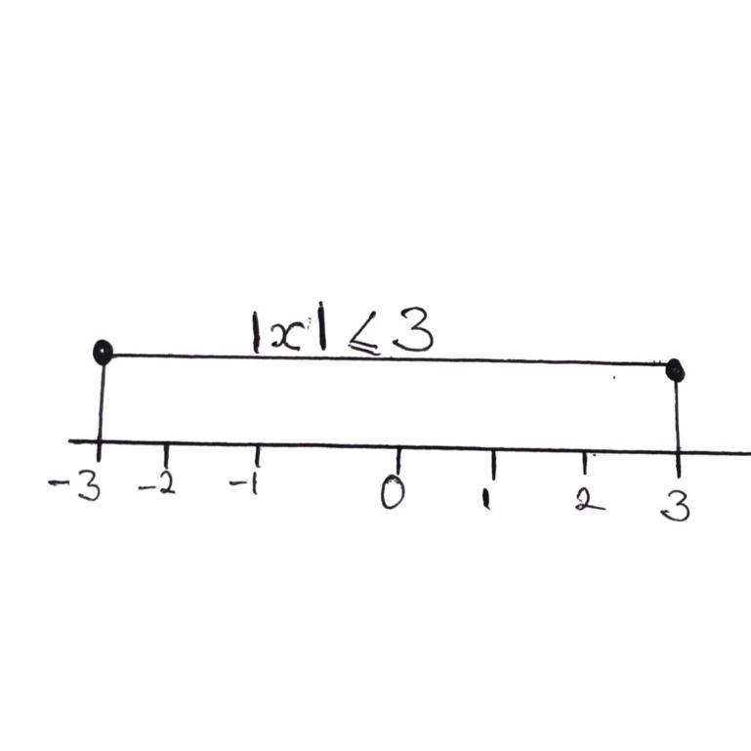

Subtract 3 from all sides,
7 - 3$≤3-3 - 2x <13 – 3$
4 $≤ - 2x <10$
Divide all sides by -2, this reverses the signs
$\frac{4}{-2}≥\frac{-2x}{-2}>\frac{10}{-2}$
$-2 ≥ x > -5$
$-5 <x≤-2$
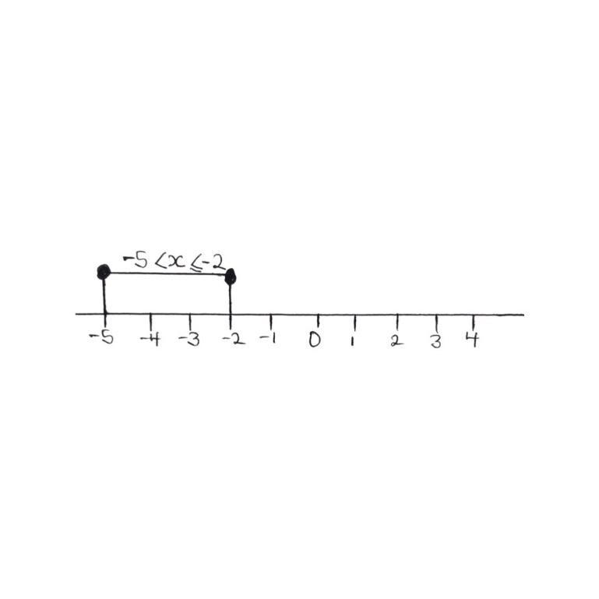

LINEAR INEQUALITIES IN TWO VARIABLES
To solve a linear inequality in two variables, it suffices to find the solution range or region for the variables that satisfy the linear inequality. It is most effective to show this region on a graph.
TRIVIA
The line of a strictly less or strictly greater inequality is a broken line (i.e. ---------)
EXAMPLE
- Find the solution set for 3x + 2y < 12
First, take the x- intercept and y – intercept. These coordinate points will be plotted as the extremities (edges) of the line.
x- intercepts (x,0)
when y = 0; 3x + 2y = 12
3x +2(0) = 12
3x = 12
x = 4
So, x- intercepts (4,0)
y- intercepts (0,y)
when x = 0; 3x + 2y = 12
3(0) +2y = 12
2y = 12
y = 6
So, y- intercepts (0,6)
Next, we plot these intercepts on the graph.
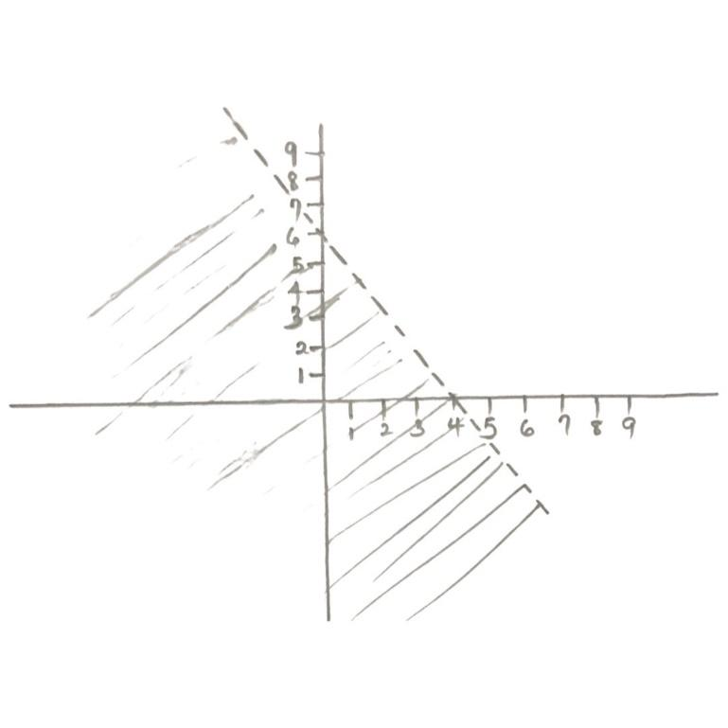
Thus, the solution set for 3x +2y <12 are all the values that fall within the shaded region.
For instance, take x = -4 and y = 9
3x + 2y = 3 (-4) + 2(9)
= -12 +18
= 6 <12
The broken time shows that points exactly on the line do not satisfy the inequality, but are simply the bounds for the solution region.
- Find the solution set for 4x +3y $≥24$
First, we find intercept values,
When y = 0
4x + 3y = 24
4x = 24
x = 6
so, x-intercept is (6,0)
when x = 0
4(0) + 3y = 24
3y = 24
y = 8
so, y- intercepts is (0,8)
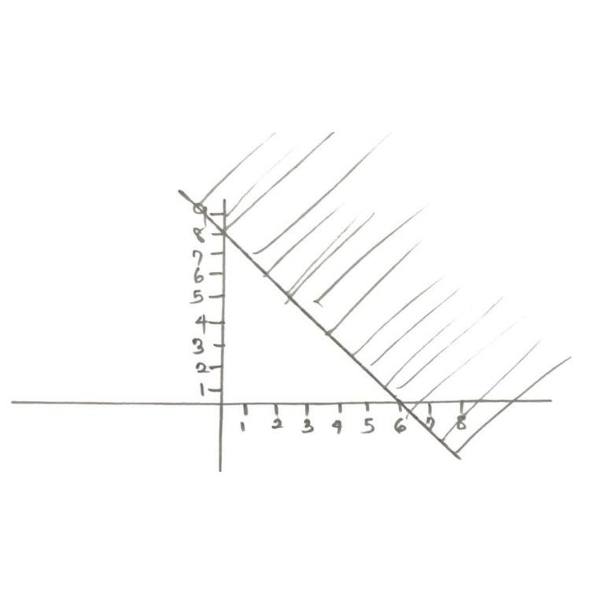
The line is solid (i.e. unbroken) since 4x +3y $≥24$
4x +3y = 24 or 4x + 3y > 24
That is, the set of values on the line also satisfy the inequality in this case.
SIMULTANEOUS LINEAR INEQUALITIES
In solving simultaneous linear inequalities, we seek to find the solution set that satisfies both inequalities at the same time. It therefore suffices to plot each inequality first, then identify the region where both individual solution sets overlap. That would be our required result.
Example
- Determine the region containing the solution of
4x – y $≤8-----------------\left(i\right)$
3x + 2y > 12$-----------------(ii)$
First, we intercept for each of the inequalities
When y= 0, 4x – y = 8
x = 2
When x= 0, 4x – y= 8
y = -8
So, (2,0) and (0, -8) are the intercepts for (i)
When y = 0, 3x + 2y = 12
x = 4
when x = 0; 3x +2y = 12
x = 4
So, (4,0) and (0, 6) are the intercepts for (ii)
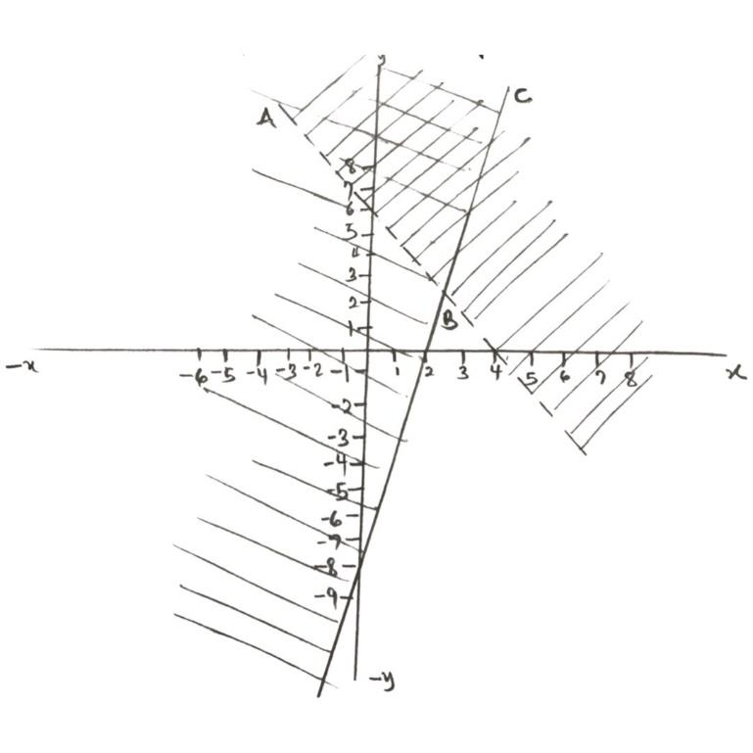
Thus, the region bounded by ABC represents the solution set for the simultaneous linear inequalities, since that is where the two individual solution regions overlap.
DRILLS
- Solve $\frac{5x - 1}{3} - \frac{1-2x}{5} ≤8 + x$
- Evaluate the combined inequality -3x < 5 – 3x $≤11$
- Determine the solution set for 5x +2y $≤17$
- What is the range of values of x for which 2x +6>2 and x – 4<1 are both satisfied?
- One class in a school has x boys and y girls. The class cannot take more than 40 students. It is found that more than half of the students are boy, but there are always at least 14 girls.
- Write down the inequalities in terms of x and y.
- Draw graphs to show these inequalities in (a)
- Shade properly the area that correctly describes the situation above.
SOLUTION TO DRILLS
- $\frac{5x - 1}{3} - \frac{1-2x}{5} ≤8 + x$
$$\frac{5(5x - 1) -3 (1-2x)}{15} ≤ 8 + x$$
$$5(5x - 1) -3 (1-2x)≤ 15(8 + x)$$
$$25x - 5 - 3+ 6x≤120+15x$$
$$25x +6x - 15x ≤120 +5+3$$
$$16x ≤128$$
$$x ≤8$$
- -3x < 5 – 3x $≤11$
$$-3 -5<5-5-3x ≤11-5$$
$-8 < - 3x ≤6$
$$\frac{8}{3}>x≥-2$$
$-2≤x<\frac{8}{3}$
- 5x +2y $≤17$
y = 0 $→5x=17→x=\frac{17}{5}=3.4$
x = 0 $→2x=17→y=\frac{17}{2}=8.5$
So, (3.4, 0) and (0, 8.5) are the intercepts
Next, we plot
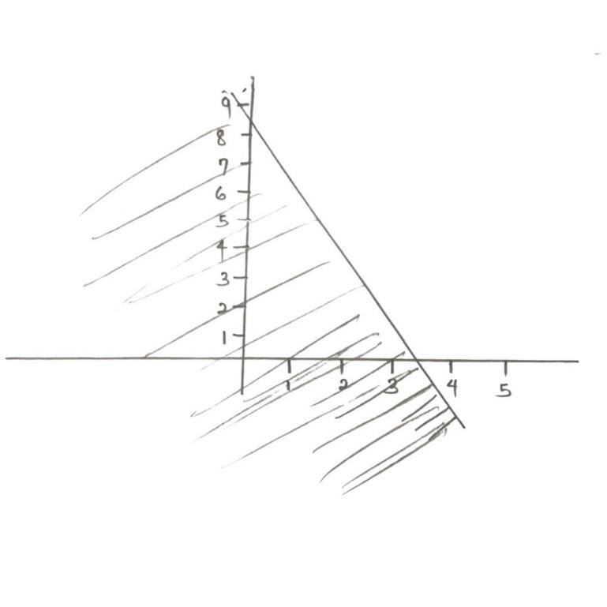
- To find the range of values that satisfy both inequalities, we first reduce the two inequalities via subject of formula.
- 2x +6 > 2
2x > 2 – 6
2x > - 4
x > -2
- x – 4 <1
x< 5
So, x > -2 and x < 5
-2 < x<5
- x + y $≤40-------------\left(i\right)$
x > 20$-------------\left(ii\right)$
y $≥14------------\left(iii\right)$
We now have our inequalities, lets proceed to plot
For x + y $≤40, we need intercepts$
y = 0 $→x = 40$
x= 0 $→y = 40$
So, (40, 0) and (0, 40) are the intercepts
Thus, only the region ABC satisfies all three inequalities, with the bounds, being the coordinate points at A,B and C.

LINEAR INEQULITIES
3x +2y < 12
x-intercept: (y=0)
3x + 2(0) = 12
3x = 12
x = 4
x-intercept: (4,0)
y-intercept: (x=0)
3(0) +2y = 12
y = 6
y-intercept (0,6)
LINEAR INEQULITIES
4x + 3y $≥24$
x-intercept (y=0)
4x +3(0) = 24
4x = 24
x = 6
x-intercept (6,0)
y-intercept (x=0)
4(0) + 3y = 24
y = 8
y-intercept (0,8)
(3,4) x = 3, y = 4
4 (3) + 3(4) = 12 +12 = 24

